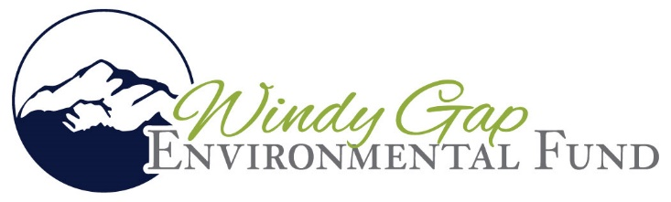

Windy Gap Environmental Fund, a fund of the Grand Foundation awards Grants in Fourth Year of funding and accepting Letters of Interest (LOI) for the 5th year
In its fourth year of grant funding, the Windy Gap Environmental Fund (WGEF), of the Grand Foundation, has awarded one Grand County organization a grant. The WGEF Committee awarded $2,745,183 in 2025, in addition to $1,690,323.21 of grant funding allocated in 2022-2024, for a total of nearly $5 million.
The largest grant awarded in December 2025 was $1,231,675 to Three Lakes Watershed Association and the Town of Grand Lake for the implementation of the Stormwater Management Plan (SWMP) developed on the west side the moraine, including all water drainage and flow from Rocky Mountain National Park through Thomasson Park and down Woodpecker Hill.
Historical grants awarded include:
- $660,000 to the Rocky Mountain Conservancy to support the implementation of the first phase of the Kawuneeche Valley Ecosystem Restoration Project.
- $250,000 to Three Lakes Watershed Association/Sanitation District for the design work for the Septic to Sewer Conversion.
- $401,179 to Learning by Doing for its final design and implementation of the Willow Creek Restoration Project.
- $25,000 to Learning by Doing for the design of a stream restoration project at Kaibab Park.
- $150,000 to the Town of Fraser to complete a stormwater infrastructure survey.
- $104,144 to the Grand Lake Recreation Foundation for design of river restoration of the Colorado River in the vicinity of the Red Top Valley Ditch diversion.
- $190,850 to Grand County Water Information Network for Union Pacific Railroad Moffat Tunnel discharge monitoring
- $532,455 to Three Lakes Watershed Association for a feasibility study of the invasive opossum shrimp population to improve water quality in Grand Lake
- $650,000 to Trout Unlimited for the restoration and enhancement of the Colorado River above Windy Gap Reservoir
The WGEF is administered and facilitated by the Grand Foundation, and has a robust committee which reviews proposals and discusses grant funding. The committee is composed of three representatives from the Northern Water’s Municipal Subdistrict and three from the Upper Colorado Watershed Environmental Team. Rounding out the committee is the Executive Director and a Board Member of the Grand Foundation.

Construction of Chimney Hollow Reservoir began in August 2021 after the Municipal Subdistrict won a federal lawsuit in the first round that challenged the permit issued by the Bureau of Reclamation and Army Corps of Engineers. The Municipal Subdistrict then settled during the appeal process, which required a $15 million contribution throughout the four-year construction timeline that will be administered and facilitated by the Grand Foundation to pay for projects that enhance the Colorado River and its many tributaries in Grand County.
The Windy Gap Environmental Fund is announcing its fourth funding cycle. At this time, they are requesting a Letter of Intent by June 27, 2025, please visit https://grandfoundation.com/Grants/Windy-Gap-Fund for more information on how to apply.
Grants are available to 501©3 non-profit organizations to fund projects that improve aquatic and riparian habitat or water quality in the Colorado River upstream from Windy Gap Reservoir and below to its confluence with Williams Fork. Evaluators will consider projects that address impacts caused by the Windy Gap Project such as increased Colorado River water temperatures, sediment transport and aquatic health, as well as nutrient levels in the Three Lakes. Funding will also be considered for proposals that provide benefits such as improving aquatic species diversity, reducing silt releases from Windy Gap Reservoir, reducing rooted vegetation, improving fish movement and enhancing waterfowl and migratory birds habitat. Projects that address wildfire, wildfire resilience and post-fire restoration, drought resilience or maintenance of groundwater levels are of interest as well.

